CT087-3-3-RTS Realtime Systems

Objective:

This assignment has been designed for students to investigate, apply and evaluate appropriate programming methods in the planning and design of a real-time systems.

Learning Outcomes

ON COMPLETION OF THIS ASSIGNMENT YOU SHOULD BE ABLE TO DEMONSTRATE THE FOLLOWING LEARNING OUTCOME(S):
No. | Learning Outcome | Assessment
1 | Discuss typical real-time systems, their requirements for asynchronous operation, concurrency and robustness. (C2, PL01) | Exam
2 | Design systematic approaches for the conceptualisation, specification and design of real-time systems. (C5, PL02) | Individual Assignment (Simulation)
3 | Verify appropriate real-time systems scheduling techniques. (A5, PL09) | Individual Assignment (Research Paper)

Programme Outcomes (PO):

PLO2 - Cognitive skills

Cognitive skills relate to thinking or intellectual capabilities and the ability to apply knowledge and skills to solve problems.
Individual Assignment – Simulation (50%):
Section |  | Question Vs Taxonomy
Section |  | Affective Level
Section | Topic | 1 | 2 | 3 | 4 | 5 | PLO
Section |  | SQ | SQ | SQ | SQ | SQ
1 | Producer Side Simulation |  |  |  |  | 20% | 2
2 | Consumer Side Simulation |  |  |  |  | 20% | 2
3 | Appropriateness of concurrent/RT concepts and design |  |  |  |  | 25% | 2
4 | Asynchronous event handling |  |  |  |  | 25% | 2
5 | Presentation |  |  |  |  | 10% | 2
 | Total |  |  |  |  | 100%

PLO9 - Personal skills

Perssonal skills generally refer to the ability to engage effectively in self-directed lifelong learning and professional pathways.
Individual Assignment - Report(50%):
Section |  | Question Vs Taxonomy
Section |  | Affective Level
Section | Topic | 1 | 2 | 3 | 4 | 5 | PLO
Section |  | SQ | SQ | SQ | SQ | SQ
1 | Introduction and background |  |  |  |  | 10% | 9
2 | Literature Review |  |  |  |  | 25% | 9
3 | Methodology |  |  |  |  | 20% | 9
4 | Analysis |  |  |  |  | 20% | 9
5 | Discussion and Evaluation |  |  |  |  | 20% | 9
6 | References/Citations |  |  |  |  | 5% | 9
 | Total |  |  |  |  | 100%

Submission Requirements
Assignment Handout Date : 19th December 2022

Assignment Due Date : 12th March 2023 (No Extensions!)

Individual Assignment – 2211CS/CS-DA

Assignment Scenario

Passenger Airliner Flight Management System

Passenger airliners are complex real-time systems managing and coordinating a number of processes. A typical flight system is comprised of a number of subsystems/processes, each responsble for some aspect of the flight. The figure below illustrates some of the processes the flight system must coorindate and manage. For example, the system is continually monitoring weather conditions, whilst at the same time measuing altitude and pinging wayfinders to determine if they are on the right course. Each of these may result in some action being taken; For instance, data from the weather sensory system may require the flight control to reduce speed (engines) and change altitude (wing flags).

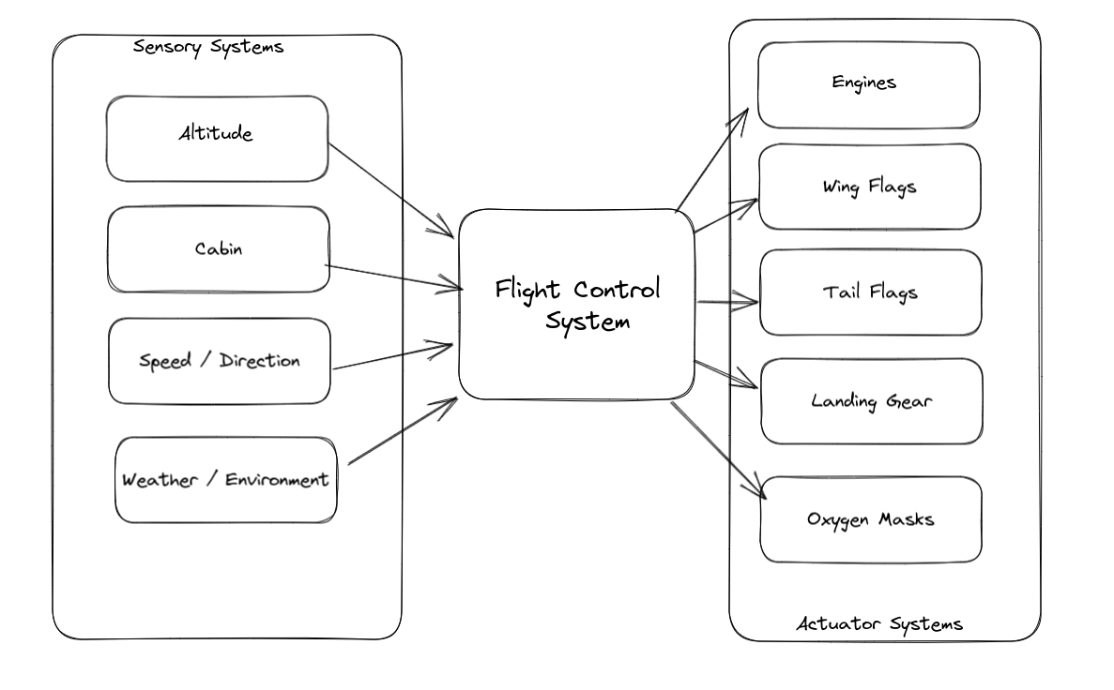

For the purposes of your RTS assignment you are required to simulate a flight management system (your simulation does not have to match the above illustration exactly). The title of your investigation is: Investigating How Programming Design Effects Real-Time Performance - A Simulation of A Flight Control System.

Instructions

The assignment is divided into 2 parts, Simulation (code) and Investigation Report

Part 1: Simulation
Using any concurrent programming language, simulate a Flight Control System. Your simulation must utilise RabbitMQ (or any other messaging system) to facilitate communication between the various components of the system, and feature sensory and actuator based processes. You are required to devise your own business logic so as to be able to provide data/input the the sensors and the conditions under which the Flight Control system will activate the actuators.

Additional marks are available for the simulation of the following:

- Sudden loss of cabin pressure
- Landing of the aeroplane (ie switching from cruising mode to landing mode)

Part 2: Investigation Report (3000-4000 words)

The second part of the assignment requires you to research and document how different programming concepts/design effect the performance of your system. This will require to you iteratively implement, measure and document the performance of the system, making tweaks and changes to your code as you go along. Using appropriate benchmarking and profiling, are are required to analyse the speed and efficiency of your simulation.

The structure of the report is as follows:

Introduction
Background (Literature Review)
Simulation Design (Investigation Methodology)
Results and Discussion
Conclusion
References

The format of your report is in the form of a research paper. (See below)
Research Paper Structure:
TITLE
Your Name and TP

Abstract
One (1) paragraph that is a brief summary of the entire proposal, typically ranging from 150 to 250 words. It is different from a problem statement in that the abstract summarizes the entire proposal, not just mentioning the study’s purpose or hypothesis. A good abstract accurately reflects the content of the paper, while at the same time being coherent, readable, and concise.

Introduction
Introduce the reader to your paper, including a brief introduction to the general subject area and how your topic is related. Briefly point out why it is a significant topic and what contribution your work will make. .At the end of your introduction, you can add a paragraph to explain the outline of your paper. The outline is the skeleton of your document. It shows how various sections in your proposal are connected and gives the reader an indication of the logical development of your research paper.

Research Background / Literature Review
This section provides a brief literature review and the background for the research problem and illustrates to the reader that the researcher is knowledgeable about the scope of the theory. Research as many studies pertaining to the topic area as possible, and summarize them in a succinct manner. The literature review should focus on real-time considerations (latency etc) and their implications for programming design/concepts. Your LR should look to discuss how programming performance is determined through an analysis of testing and (mirco)benchmarking techniques. In addition you should look to appraise the available external tools.

Methodology
Describe your proposed methods in sufficient detail so that the reader is clear about the following:
- What test(s) will you be conducting?
- What resources will you require (testing and evaluation tools/software)?
- What methodology will you be using (ie how will it be conducted)?
- Why have you selected this approach (what other approaches are available)?
This section is essential to most good research papers. How you study a problem is often as important as the results you collect. This section includes a description of the general means through which the goals of the study will be achieved: methods, materials, procedures, tasks, etc. - You should also provide an outline of the structure of your 2 simulations here

Results and discussion
In this section you provide a detailed explanation of the results of your tests and discuss your findings. Include screen shots, source code extracts, tables and charts to support your discussion.

Conclusion
Provide qualified conclusion of your research by reflecting on what you have found out and its importance to real-time development.

References
List all publications cited in your proposal. Use the style recommended by the school or your supervisor. You should use the APA referencing system (see the library webpage of APU).
Use very recent and reliable references from journal articles, conference proceedings, books, theses, etc. it is recommended to use a reference manager (such as EndNote, Mendeley, etc) to help you in formatting the references and save your time.

